CS 2302 Data Structures

Fall 2019

Lab Report #6

Due: November 15, 2019

Professor: Olac Fuentes

TA: Anindita Nath

**Introduction**

In this lab the task was to implement methods in given code that required translating one version of a graph representation to other version of graphs as well as finding a solution to a riddle using graphs and pathing to do so.

**Proposed Solution Design and Implementation**

For the lab i wanted to figure out what was a legal state and what was an illigal state. Once i found that out i wanted, to then find all paths through the legal states useing only legal conections. Then i would use the internal display methods to show each graph as well as their paths

**Experimental Results**

**Part 1:**

This was very simple to implement. It was jsut a simple conversion from one graph to another

AM GRAPH:

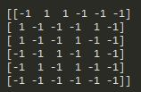

AM-EL Graph:



AM-AL Graph:



AL Graph:



AL-EL Graph:



AL-AM Graph:



EL Graph:



EL-AM Graph:



EL-AL Graph:



**Part 2:**

This was very simple to implement. First thing i did was find all legal states:

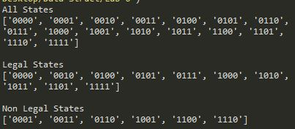

I then found all valid paths and inserted edged between them to form my graph:



Then useing depth first and breath first searches i found the best paths through:

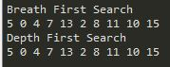

**Overall Lab Results:**

Overall their was not much variance in the results dues to having a very specific question to solve.

**Conclusion**

After finishing the lab i think graphs can be really usefull. Between learning how to find the fasted paths and how things link together i can think of nermouse problems that would greatly benefit from useing a graph to solve the issue.

**Appendix**

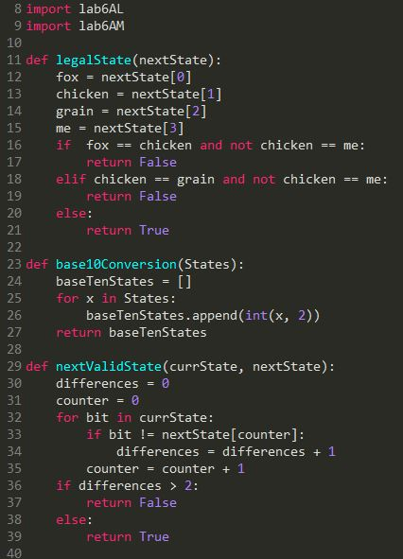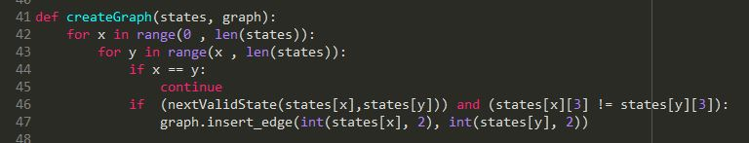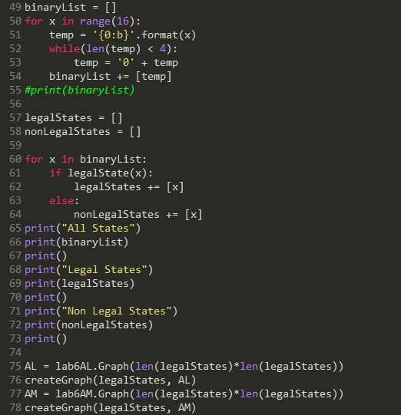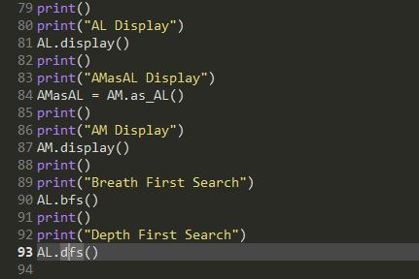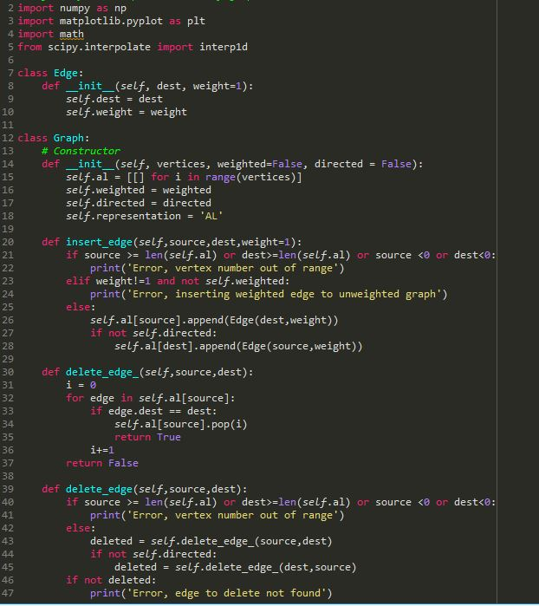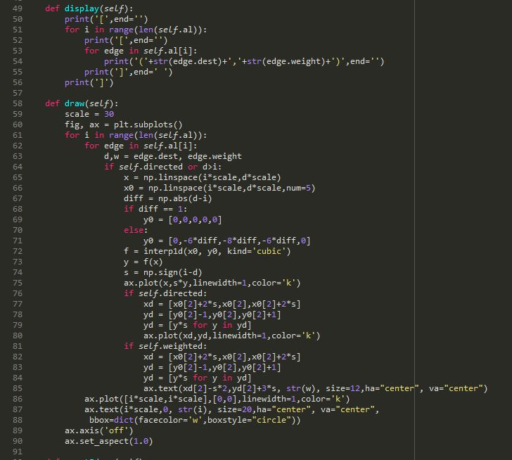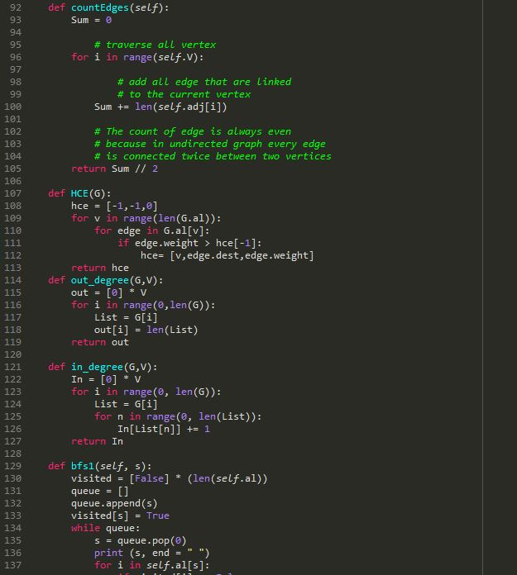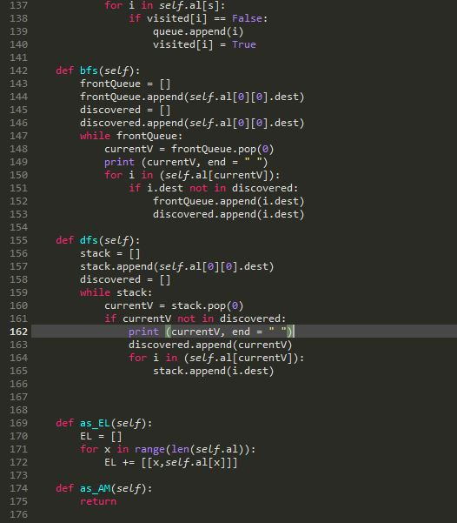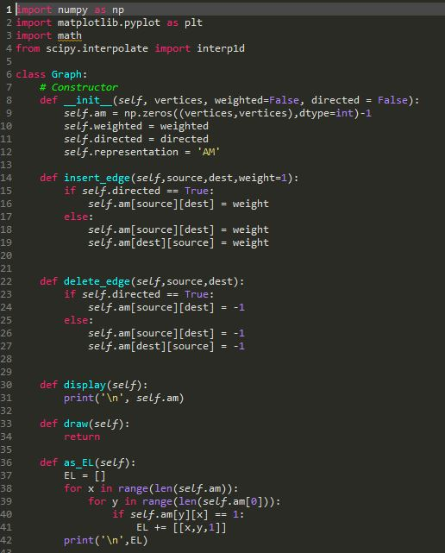

*I certify that this project is entirely my own work. I wrote, debugged, and tested the code being presented, performed the experiments, and wrote the report. I also certify that I did not share my code or report or provided inappropriate assistance to any student in the class*

Justus Frausto